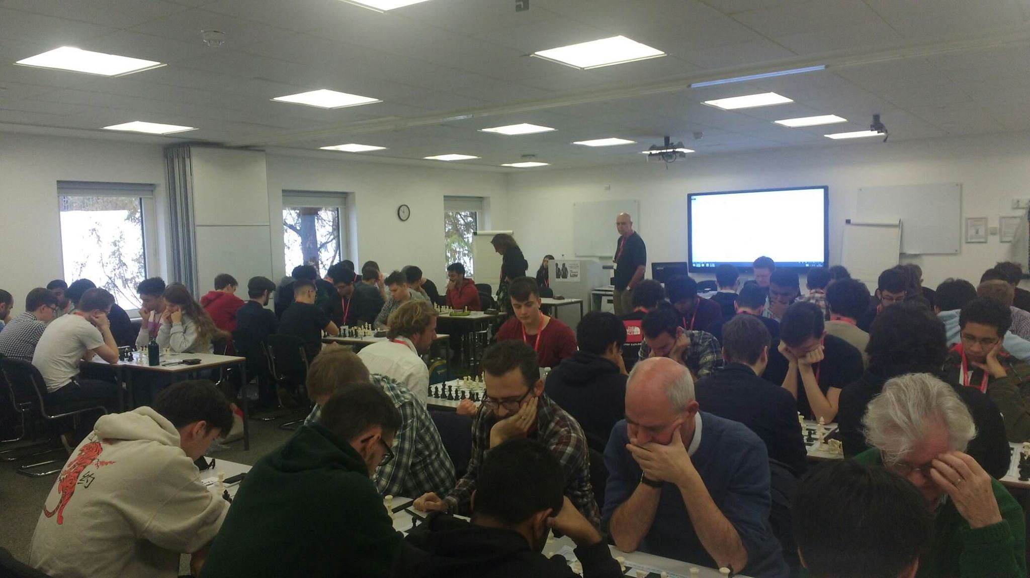
UNBEATABLE UCL UNITE TO WIN TITLE
UCL put in a fine performance to win the 2020 Southern Qualifier in London for the 2019-20 Season, which will put them in good stead for the next year’s Grand Final.
Position | TEAM | WINS | DRAWS | DEFEATS | (+/-) | Match Points
1st | UCL A (Q) | 5 | 0 | 0 | 16.5 | 5
2nd | LSE A (Q) | 4 | 0 | 1 | 15.5 | 4
3rd | LSE C (Q) | 3 | 1 | 1 | 10.5 | 3.5
4th | Mushrooms (Q) | 3 | 0 | 2 | 15 | 3
5th | Reading B (Q) | 2 | 2 | 1 | 11.5 | 3
6th | LSE B (Q) | 3 | 0 | 2 | 11 | 3
7th | Kings College A (Q) | 3 | 0 | 2 | 10 | 3
8th | Durham Alumni | 2 | 1 | 2 | 11 | 2.5
9th | UCL B | 2 | 1 | 2 | 8.5 | 2.5
10th | Royal Holloway A | 2 | 0 | 3 | 9 | 2
11th | Kings College C | 1 | 2 | 2 | 8.5 | 2
12th | Kings College B | 1 | 2 | 2 | 6.5 | 2
13th | Barbarians | 0 | 3 | 2 | 8 | 1.5
14th | Reading A | 0 | 3 | 2 | 6 | 1.5
15th | Royal Holloway B | 1 | 0 | 4 | 6 | 1
16th | Queen Mary’s | 0 | 0 | 5 | 5.5 | 0
The main drama came in round two, where they narrowly squeezed passed LSE A 2.5-1.5, which turned out to be a crucial result as LSE finished in second place ruing their missed chances but pleased to join them in qualification with their ‘C’ team impressively punching above their weight to eventually finish third.
Our thanks to the University College of Law for again kindly hosting the event, and to Jacques Parry who came along at the last minute to valuably and diligently assist with the arbitrating.
23rd November 2019

Round One:
Mushrooms 1.5-2.5 UCL A
Royal Holloway B 1-3 LSE C
Royal Holloway A 4-0 UCL B
LSE B 1-3 Kings College A
Queen Mary’s 2-2 Reading B
LSE A 3.5-1.5 Durham Alumni
Kings College C 2-2 Barbarians
Reading A 2-2 Kings College B
Round Two:
Royal Holloway B 0-4 Mushrooms
Barbarians 2-2 Reading A
Kings College B 2-2 LSE C
Kings College A 4-0 Royal Holloway A
Durham Alumni 4-0 Queen Mary’s
Reading B 2-2 Kings College C
UCL B 0.5-3.5 LSE B
UCL A 2.5-1.5 LSE A
Round Three:
Kings College C 2.5-1.5 Durham Alumni
LSE C 3-1 Royal Holloway A
Kings College A 0-4 UCL A
Reading A 0.5- Reading B
Royal Holloway B 1-3 UCL B
Mushrooms 4-0 Kings College B
LSE A 4-0 Queen Mary’s
LSE B 3-1 Barbarians
Round Four:
UCL A 4-0 LSE C
Reading B 1-3 LSE B
UCL B 2-2 Barbarians
Queen Mary’s 1-3 Royal Holloway B
Durham Alumni 2-2 Reading A
Kings College C 0.5-3.5 Kings College A
LSE A 2.5-1.5 Mushrooms
Royal Holloway A 4-0 Kings College B
Round Five:
Kings College A 0-4 LSE A
LSE B 0.5-3.5 UCL A
Kings College B 2.5-1.5 Queen Mary’s
Mushrooms 4-0 Royal Holloway A
Royal Holloway B 1-3 Durham Alumni
Reading A 1-3 UCL B
LSE C 2.5-1.5 Kings College C
Barbarians 1-3 Reading B

TEAM | Round 1 | Round 2 | Round 3 | Round 4 | Round 5 | TOTAL
LSE A
Daniela Movileanu | ✔ | 1/2 | ✔ | ✔ | ✔ | 4.5 SILVER
Thomas Goldie |  |  | ✔ | ✔ | ✔ | 3
Abhinav Bathula | ✔ | ✔ | ✔ |  | ✔ | 4 BRONZE
Aaneel Shalman | ✔ |  | ✔ | 1/2 | ✔ | 3.5
LSE B
Girinath Haridas |  | ✔ | ✔ |  |  | 2
Suneet Kooner |  | ✔ |  | ✔ |  | 2
Yixin Guo |  | ✔ | ✔ | ✔ |  | 3
Christian Schiøler Hansen | ✔ | 1/2 | ✔ | ✔ | 1/2 | 4 BRONZE
LSE C
Mateusz Masiak | ✔ | ✔ | ✔ |  |  | 3
Roberto José Patiño Guzmán | ✔ |  | 1/2 |  | ✔ | 2.5
Farid Abou Jaoude | ✔ |  | 1/2 |  | 1/2 | 2
Dhanush Barathan |  | ✔ | ✔ |  | ✔ | 3
Queen Mary’s A
Malcolm Ron Pereira |  |  |  |  | 1/2 | 0.5
Justinas Kovalenkinas (board 3) |  |  |  |  |  | 0
Muhammad Muneeb (board 2) | ✔ |  |  |  | ✔ | 2
Jiyaad Hussian |  |  |  | ✔ |  | 1
Barbarians
Unknown | ✔ | ✔ |  | ✔ |  | 3
Kane Toh | ✔ | ✔ | ✔ | ✔ | ✔ | 5 GOLD
Unknown
Unknown
Royal Holloway A
Elizabeth Ivanov | ✔ |  |  | ✔ |  | 2
Jonas Erbe | ✔ |  | 1/2 | ✔ |  | 2.5
Francesco Santi | ✔ |  | 1/2 | ✔ |  | 2.5
Lucas Berger | ✔ |  |  | ✔ |  | 2
Royal Holloway B
Bence Horanyi |  |  |  | ✔ |  | 1
Akadil Zharimbet |  |  |  | ✔ | ✔ | 2
Jordan Packham |  | ✔ |  | ✔ |  | 2
Matthew Kenworthy | ✔ |  |  |  |  | 1
Kings College A |  |  |  | ✔ |  | 1
Maxim Dunn | ✔ | ✔ |  |  |  | 2
Federico Barbero | ✔ | ✔ |  |  |  | 2
Stephanie Gu | ✔ | ✔ |  | ✔ |  | 3
Tamerlan Zhutayev |  | ✔ |  | ✔ |  | 2
Kings College B
Feras Fayez |  |  |  |  |  | 0
Aren Kasparian | ✔ | ✔ |  |  |  | 2
Pierre-Olivier Pitt | ✔ | ✔ |  |  | ✔ | 3
Shumeng Liu |  |  |  |  | ✔ | 1
Kings College C
Kasper Fiscella |  |  | ✔ |  | ✔ | 2
F. Savier Gavao de Castro |  |  |  | 1/2 |  | 0.5
Tom Flaskamp | ✔ | ✔ | 1/2 |  | 1/2 | 3
Kevin Arness | ✔ | ✔ | ✔ |  |  | 3
Reading A
Mridul Manoj | ✔ |  |  | ✔ |  | 2
Shaun Rodrigues
Matthew Brewer |  | ✔ |  |  |  | 1
James Connors | ✔ | ✔ |  | ✔ |  | 3
Reading B
Gareth Qian | ✔ | ✔ | 1/2 | ✔ | ✔ | 4.5 SILVER
Thomas Hook |  | ✔ | ✔ |  |  | 2
Giovanni Taffarello |  |  | ✔ |  | ✔ | 2
Aleem Yawar | ✔ |  | ✔ |  | ✔ | 3
Durham Alumni
Unknown |  | ✔ |  |  | ✔ | 2
Phil Purcell | 1/2 | ✔ | ✔ | ✔ | ✔ | 4.5 SILVER
Yoseph Helbawi |  | ✔ | 1/2 | ✔ |  | 2.5
Elias Hakimi |  | ✔ |  |  | ✔ | 2
Mushrooms
Chris Briscoe |  | ✔ | ✔ |  | ✔ | 3
Luis Ortiz Sanchez | 1/2 | ✔ | ✔ |  | ✔ | 3.5
Rory O'Kelly | ✔ | ✔ | ✔ | ✔ | ✔ | 5 GOLD
Nick Faulks |  | ✔ | ✔ | 1/2 | ✔ | 3.5
UCL A
Michael Green | ✔ | 1/2 | ✔ | ✔ | ✔ | 4.5 SILVER
Max Hort | 1/2 | ✔ | ✔ | ✔ | ✔ | 4.5 SILVER
Abhiram Sasitharan |  |  | ✔ | ✔ | ✔ | 3
Wei Zhong | ✔ | ✔ | ✔ | ✔ | 1/2 | 4.5 SILVER
UCL B
Samuel Fedida |  |  | ✔ |  | ✔ | 2
Andreas Pas |  |  | ✔ |  | ✔ | 2
Tommy Sin |  |  |  | ✔ |  | 1
Matteo Ceschia |  | 1/2 | ✔ | ✔ | ✔ | 3.5

