Wonderful Wandering Dragons dominate Scotland at 2020 Chess!
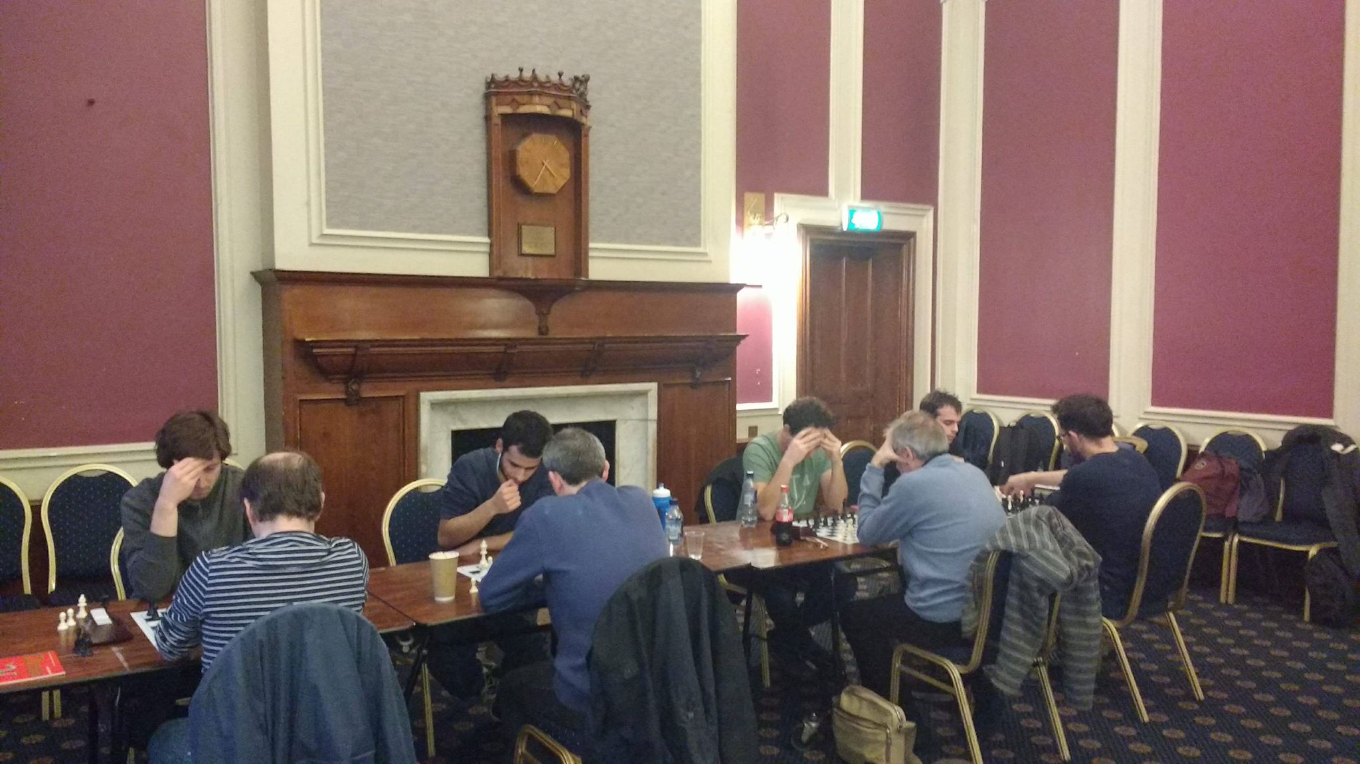
Wandering Dragons became the first club side in 2020 history to win a qualifier, and deservedly so after an excellent display with both their sides significantly improving on last year’s performance.
They faced a tough opening round against Glasgow though eventually managed to prevail 3-1, and went on to extract sweet revenge over the hosts and former Scottish champions Edinburgh University in round two with the same resounding scoreline.
Strathclyde University started strongly with victories against debutants Edinburgh Chess Club and a narrow 2.5-1.5 win over Wandering Dragon’s ‘B’ team but became unstuck in round three against their ‘A’ team going down 3-1.
The momentum was firmly with Wandering Dragons ‘A’ as they defeated their ‘B’ team in the penultimate round ensuring qualification, and only needing to avoid defeat against Edinburgh Chess in their final match to clinch the title which they managed to achieve with a tight but fair 2-2 draw.
The focus was switched onto who would join them at the Grand Final; Glasgow University ‘A’ reacted superbly from their opening round’s disappointment comprehensively sweeping past all their opponents to take second place.
This was at Strathclyde’s unfortunate expense however as their defeat against them in final round made them agonizingly miss the cut only on game points, and Edinburgh University and Wandering Dragons B took full advantage claiming the last two spots for the Grand Final taking place next year.
It was an exhilarating tournament, which wouldn’t have been possible without the help of Kughan Ravindran who booked the fine venue at Edinburgh University and Ben Raine who diligently assisted with the pairings and arbitrating. Our sponsors Chess and Bridge, Chess Openings Wizard and Internet Chess Club were most kind in providing the equipment and prizes for the event.

Round Results Scotland 2020 Chess Qualifier 11th November 2017

Round One:
Wandering Dragons 3-1 Glasgow A
Stirling B 0-4 Strathclyde B
Edinburgh Chess Club 1-3 Strathclyde A
Stirling A 0-4 Edinburgh
Wandering Dragons B 3-1 Glasgow B
Round Two:
Glasgow B 2-2 Stirling A
Edinburgh 1-3 Wandering Dragons A
Glasgow A 4-0 Stirling B
Strathclyde B 0-4 Edinburgh Chess Club
Wandering Dragons B 1.5-2.5 Strathclyde A
Round Three:
Strathclyde A 1-3 Wandering Dragons A
Stirling 0-4 Glasgow A
Stirling B 0-4 Glasgow B
Wandering Dragons B 4-0 Strathclyde B
Edinburgh Chess Club 2.5-1.5 Edinburgh University
Round Four:
Edinburgh 4-0 Strathclyde B
Wandering Dragons A 4-0 Wandering Dragons B
Glasgow A 3-1 Edinburgh Chess Club
Strathclyde A 4-0 Glasgow B
Stirling A 4-0 Stirling B

Round Five:
Edinburgh Chess Club 2-2 Wandering Dragons
Wandering Dragons B 4-0 Stirling B
Strathclyde B 2.5-1.5 Stirling A
Glasgow A 3-1 Strathclyde A
Glasgow B 1.5-2.5 Edinburgh

Final Table:

Position | Team | Wins | Draws | Defeats | Score | +/-
1st | Wandering Dragons ‘A’ | 4 | 1 | 0 | 13
2nd | Glasgow ‘A’ | 4 | 0 | 1 | 12
3rd | Edinburgh | 3 | 0 | 2 | 9
4th | Wandering Dragons ‘B’ | 3 | 0 | 2 | 9
5th | Strathclyde | 3 | 0 | 2 | 9
6th | Edinburgh Chess Club | 2 | 1 | 2 | 7
7th | Strathclyde ‘B’ | 2 | 0 | 3 | 6
8th | Stirling ‘A’ | 1 | 1 | 3 | 4
9th | Glasgow ‘B’ | 1 | 1 | 3 | 4
10th | Stirling ‘B’ | 0 | 0 | 5 | 0

