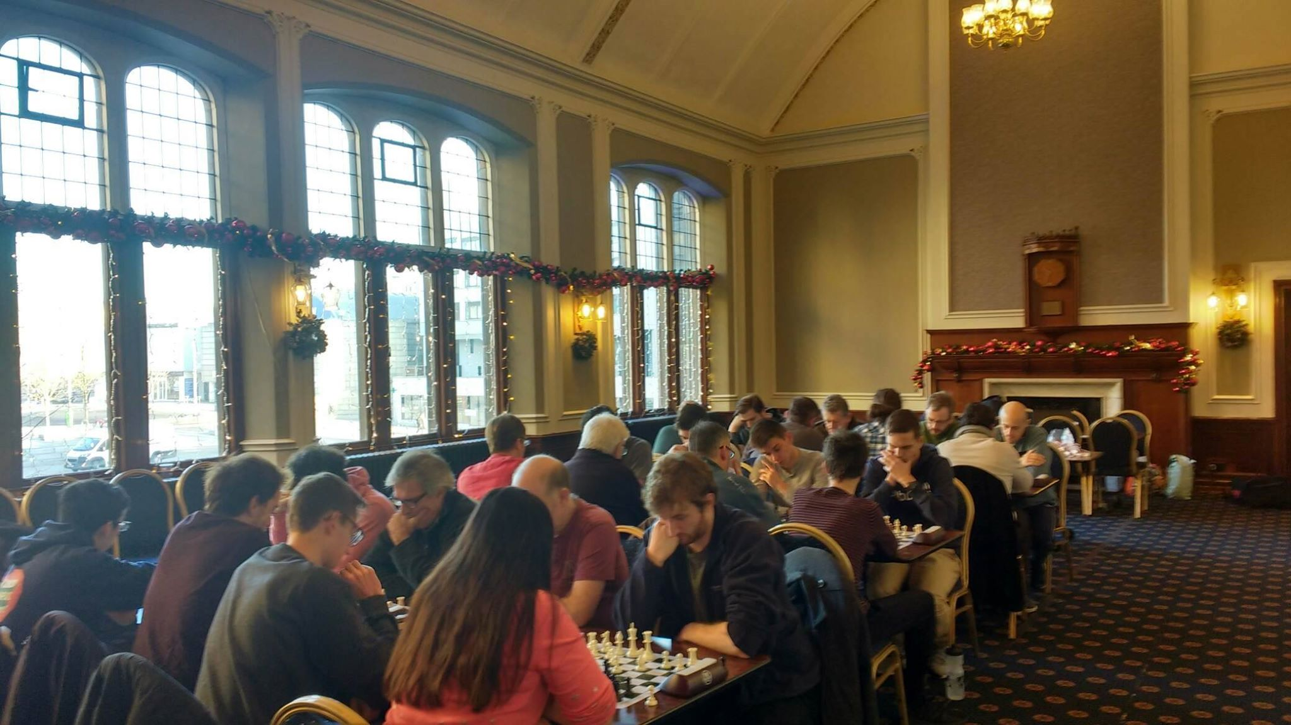

Excellent Edinburgh Excel in Edinburgh!
POSITION | TEAM | WINS | DRAWS | DEFEATS | MATCH POINTS | (game points)
1st | Edinburgh Chess Club A | 5 | 0 | 0 | 5 (Q) | 16.5
2nd | Wandering Dragons A | 4 | 0 | 1 | 4 (Q) | 13.5
3rd | Edinburgh Chess Club B | 3 | 0 | 2 | 3 (Q) | 10.5
4th | Edinburgh University A | 2 | 1 | 2 | 2.5 | 10.5
5th | Wandering Dragons B | 2 | 1 | 2 | 2.5 | 9.5
6th | Bank of Scotland | 2 | 0 | 3 | 2 | 6
7th | Edinburgh University B | 1 | 0 | 4 | 1 | 6.5
8th | Durham University D | 0 | 0 | 5 | 0 | 4

Edinburgh Chess Club A took the 2020 Scotland Title after winning all their games in the face of extremely tough competition under the beautiful Christmas lights at Teviot Row House. This was reflected by the fact that for the first time in 2020/NUCC history no single player managed to win a gold medal (5/5), so high quality were the players!
The highlight came in the second round when they dispatched their rivals Wandering Dragons A 4-0 who consequently ended up in second place. However, Wandering Dragons B on the other did give them a huge scare in round four, only being squeezed out by a 2.5-1.5 margin. From there all Edinburgh Chess Club needed to do was avoid heavy defeat in the final round which they did by beating Edinburgh University by the same scoreline.
Their ‘B’ team also qualified in a straight shootout in the final round to finish third with a narrow 2.5-1.5 win over Bank of Scotland.
Our thanks to everyone took part, and for Edinburgh University hosting the event because of the diligent efforts from William James. £156 was raised for charity in the process!

Round One:
Wandering Dragons 3-1 Edinburgh University B
Bank of Scotland 0-4 Edinburgh Chess Club A
Edinburgh Uni A 0.5-3.5 Wandering Dragons A
Edinburgh Chess Club B 4-0 Durham University
Round Two:
Edinburgh Chess Club 4-0 Wandering Dragons A
Edinburgh University B 1-3 Edinburgh Chess Club B
Edinburgh University A 3-1 Bank of Scotland
Durham University 1-3 Wandering Dragons B
Round Three:
Edinburgh Chess Club B 0.5-3.5 Edinburgh Chess Club A
Wandering Dragons A 4-0 Durham University
Bank of Scotland 2.5-1.5 Edinburgh University B
Wandering Dragons B 2-2 Edinburgh University A

Round Four:
Edinburgh Chess Club A 2.5-1.5 Wandering Dragons B
Durham 1.5-2.5 Bank of Scotland
Edinburgh Chess Club B 1-3 Wandering Dragons A
Edinburgh University B 0.5-3.5 Edinburgh University A
Round Five:
Edinburgh University A 1.5-2.5 Edinburgh Chess Club A
Wandering Dragons B 1-3 Wandering Dragons A
Edinburgh University B 2.5-1.5 Durham University B
Edinburgh Chess Club B 2.5-1.5 Bank of Scotland

TEAM | ROUND 1 | ROUND 2 | ROUND 3 | ROUND 4 | ROUND 5 | TOTAL
Edinburgh University A
Chris Wu | 1/2 | ✔ | ✔ | 1/2 | 1/2 | 3.5
Iosif Lytras |  | ✔ | ✔ | ✔ |  | 3
Martin Kopernicky |  |  |  | ✔ |  | 1
Darima Donitova |  | ✔ |  | ✔ | ✔ | 3
Edinburgh University B
Ziyan Bao |  |  |  | 1/2 | ✔ | 1.5
Nikitas Angeletos Chrysaitis |  | ✔ | ✔ |  |  | 2
Chihon Ley P. |  |  |  |  | ✔ | 1
William James | ✔ |  | 1/2 |  | 1/2 | 2
Bank of Scotland
Mike Chisolm |  |  | ✔ | 1/2 | 1/2 | 2
Jamie Mollison |  |  |  | ✔ |  | 1
Kris Baumanis |  |  | ✔ |  |  | 1
Adrià Borràs |  |  | 1/2 | ✔ | ✔ | 2.5
Edinburgh Chess Club A
Adam Bremner | ✔ | ✔ | ✔ | ✔ | 1/2 | 4.5 SILVER
Willy Rutherford | ✔ | ✔ | ✔ |  | ✔ | 4 BRONZE
Snorri Kristjansson | ✔ | ✔ | ✔ | 1/2 | ✔ | 4.5 SILVER
Andre Antunes | ✔ | ✔ | 1/2 | ✔ |  | 3.5
Edinburgh Chess Club B
Mike Ridge | ✔ | ✔ |  |  | 1/2 | 2.5
Robert Kane | ✔ |  |  |  | ✔ | 2
Benjamin Ridge | ✔ | ✔ |  |  | ✔ | 3
Keith Aitchison | ✔ | ✔ | 1/2 | ✔ |  | 3.5
Wandering Dragons, A
Alan Tate | 1/2 |  | ✔ | ✔ | ✔ | 3.5
Mark Orr | ✔ |  | ✔ | ✔ | ✔ | 4 BRONZE
Eliot Sloan | ✔ |  | ✔ | ✔ |  | 3
Neil Fleming | ✔ |  | ✔ |  | ✔ | 3
Wandering Dragons B
Jim O’Neil | ✔ |  |  |  |  | 1
Richard Kynoch | ✔ | ✔ |  | ✔ |  | 3
Isaac Browning | ✔ | ✔ | ✔ | 1/2 |  | 3.5
Lee Bishop |  | ✔ |  |  |  | 1
Durham University |  | ✔
Angus Clarke |  |  |  | 1/2 | ✔ | 1.5
Thaisen Chant
Georgy Ivankhnenko |  |  |  | ✔ |  | 1
Ed Berry |  |  |  |  | 1/2 | 0.5

