Warwick win over all challengers in opening qualifier!
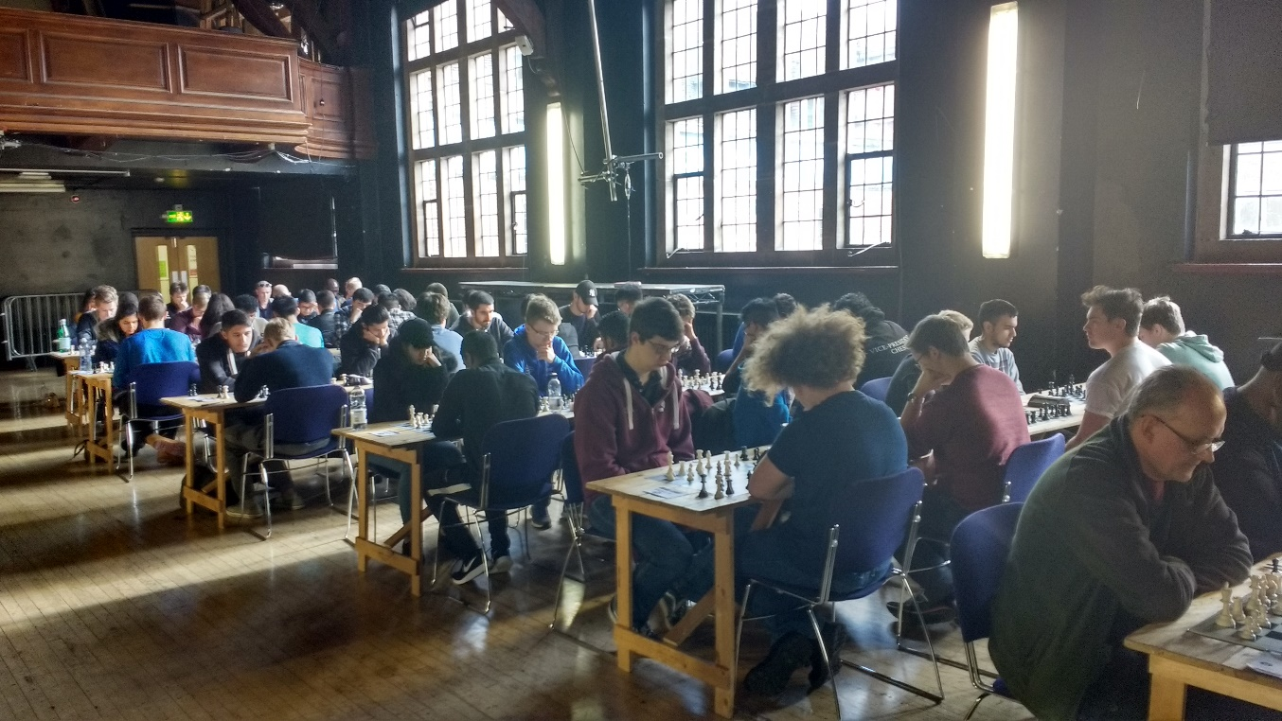
Warwick University’s A team put in a fine display to kick off the 2020 2017-18 season at the midlands qualifier in Birmingham winning all five games, demonstrating their determination to hold on to the Champions Title they had earned back in June.
After relatively straightforward victories early on, Sutton Chess Club A gave them a real fight in round four and narrowly fell short by a 2.5-1.5 margin. They will be very proud of their performance nevertheless as they eventually finished 2nd to earn a place at the Grand Final next February.
The final round thus saw a straight shootout between the hosts Birmingham University A and Warwick University A, in a match which could have gone either way Warwick finally prevailed 3-1 with Peter Batchelor (see below) capitalising on sustained pressure to complete his team’s fantastic achievement.

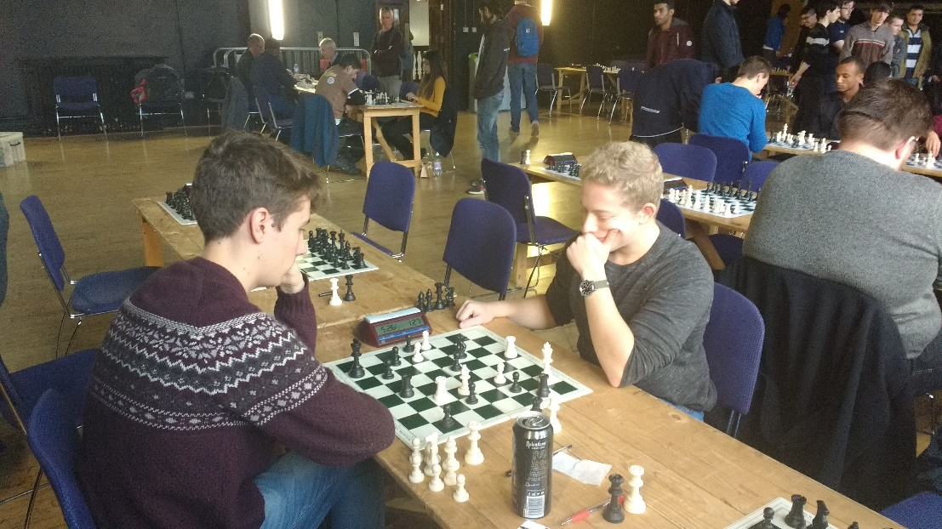

This left one remaining qualifying place up for grabs with Nottingham, Sheffield and Manchester in contention for their concluding game. It was a tough ask for Nottingham as they had to face a strong Sutton A side and fell to a 4-0 defeat, which meant that Manchester had to beat Sheffield to go through. It could have gone either way, but it ended as a thrilling 2-2 draw which just sent Sheffield to the Grand Final on game points.
Overall it was an exciting and competitive tournament with 19 teams, a healthy expansion from last time, with sides travelling from a variety of different locations with a wide range of abilities.
We were very fortunate to have a lovely playing hall which was booked months in advance by Scott Leadbetter and Birmingham University Chess Society so many thanks to them, as well as to Alexander Taylor our ECF Level One Arbiter who managed the tournament’s games diligently as ever!
Our sponsors from Chess and Bridge, Internet Chess Club and Chess Openings Wizard kindly provided the prizes for the competitors, we are most grateful.

Peter Hornsby
2020 Chess Founder and Director

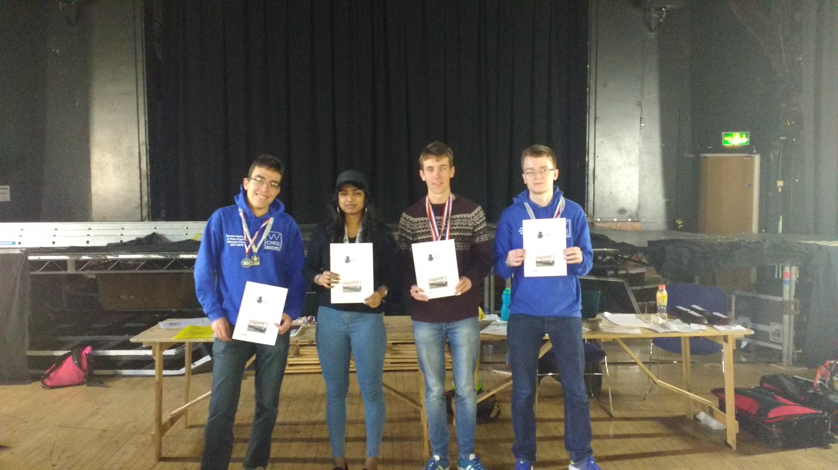
Special congratulations to those who scored 5/5 Gold Medals: James Harrison, Marek Soszynski, Anthony Stannard. 4.5 Silver Medals: Dimiter Daskalov, Peter Batchelor, Henrik Stepanyan. 4/5 Bronze Medals: Conrad Green, Abdirahman Dama, Paulina Orejuela, Jiping Li, Noel Brown, Arjan Pyda.

2020 Chess Championships 2017-18 Season Midlands Qualifier 22nd October 2017

Round 1:

Warwick B 1.5-2.5 Queen Mary’s B
Sheffield University 4-0 DEFAULT
Sutton A 4-0 Coventry A
Birmingham 4-0 Coventry C
Queen Mary A 0-4 Warwick A
Manchester 4-0 Aberystwyth B
Nottingham Society 4-0 Barbarians
Coventry B 1-3 Birmingham A
King Edwards School 1-3 Sutton Coldfield B
Aberystwyth 3-1 Reading

Round 2:
Sheffield 1-3 Birmingham A
Aberystwyth B 1-3 Queen Mary’s A
Sutton Coldfield B 1-3 Aberystwyth A
Coventry A 3.5-0.5 Warwick B
Queen Mary’s B 1.5-2.5 Birmingham B
Reading 1.5-2.5 King Edwards School
Sutton Coldfield A 3.5-0.5 Manchester
Barbarians 0-4 Coventry B
Warwick A 3.5-0.5 Nottingham Society
Coventry C 4-0 DEFAULT

Round 3:

Aberystwyth A 0-4 Sutton Coldfield A
Birmingham B 1.5-2.15 Birmingham A
Manchester 3-1 Queen Mary’s B
Sheffield 4-0 Coventry C
Queen Mary’s A 1-3 Coventry A
Nottingham Society 4-0 Reading
King Edwards School 1.5-2.5 Aberystwyth B
Warwick B 2.5-1.5 Sutton B
Coventry B 1-3 Warwick A
DEFAULT 0-4 Barbarians

Round 4:

Coventry C 0-4 Warwick B
Aberystwyth B 0-4 Sheffield
Birmingham A 4-0 Aberystwyth
Manchester 4-0 Birmingham B
Warwick A 2.15-1.5 Sutton A
Sutton Coldfield B 1-3 Queen Mary’s A
Queen Mary’s B 0-4 Barbarians
Coventry A 0.5-3.5 Nottingham Society
Reading 2-2 Coventry B
DEFAULT 0-4 King Edwards School

Round 5:

Warwick A 3-1 Birmingham A
King Edwards School 0-4 Queen Mary’s B
Queen Mary’s A 2-2 Aberystwyth A
Birmingham B 1-3 Warwick B
Barbarians 0-4 Coventry A
Sutton Coldfield B 3-1 Reading
Manchester 2-2 Sheffield
Sutton A 4-0 Nottingham Society
Coventry C 1.5-2.5 Coventry B
Aberystwyth B 4-0 DEFAULT

FINAL TABLE:

