The Inaugural National University Chess Championships South London 6th February 2016
Sponsored by:
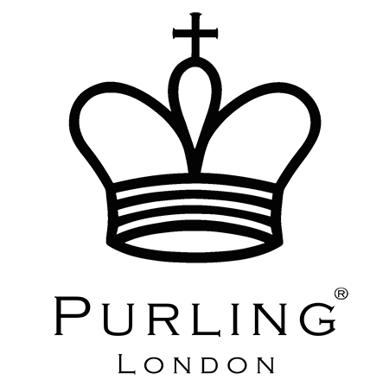

University | Wins | Draws | Defeats | Total points | Position
Oxford | 5 | 1 | 0 | 16 | 1st
UCL C | 4 | 2 | 0 | 14 | 2nd
Kings College A | 4 | 1 | 1 | 13 | 3rd
Oxford B | 4 | 0 | 2 | 12 | 4th
Sussex | 4 | 0 | 2 | 12 | 5th
LSE B | 4 | 0 | 2 | 12 | 6th
Royal Holloway A | 3 | 1 | 2 | 10 | 7th
UCL A | 3 | 0 | 3 | 9 | 8th
Bath | 3 | 0 | 3 | 9 | 9th
Royal Holloway B | 3 | 0 | 3 | 9 | 10th
Kings College B | 2 | 2 | 2 | 8 | 11th
UCL B | 1 | 4 | 1 | 7 | 12th
Surrey | 2 | 1 | 3 | 7 | 13th
Kent | 2 | 0 | 4 | 6 | 14th
Queen Mary’s | 1 | 3 | 3 | 6 | 15th
LSE A | 1 | 3 | 3 | 6 | 16th
Reading | 1 | 1 | 4 | 4 | 17th
Lions | 1 | 1 | 4 | 4 | 18th
Dragons | 1 | 0 | 5 | 3 | 19th
Goldsmiths | 0 | 2 | 4 | 2 | 20th

AWARDS:

Champions:

Oxford University

Board prizes:

1: Oxford A
2: Oxford A
3: Oxford A
4: Kings College B

Results between teams:

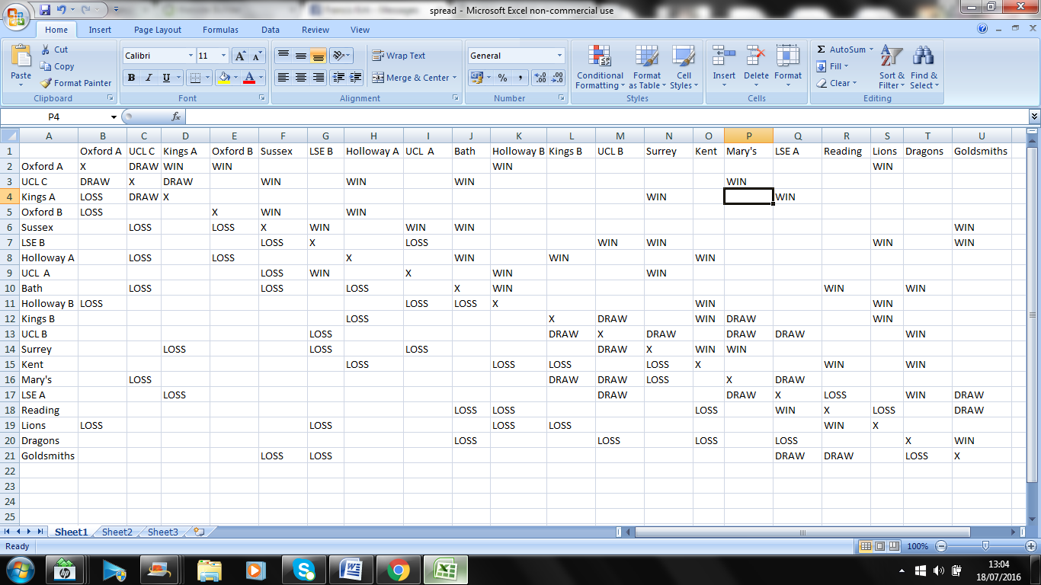

(N.B a handful of exact results are missing due to scorecards not being filled in properly)

