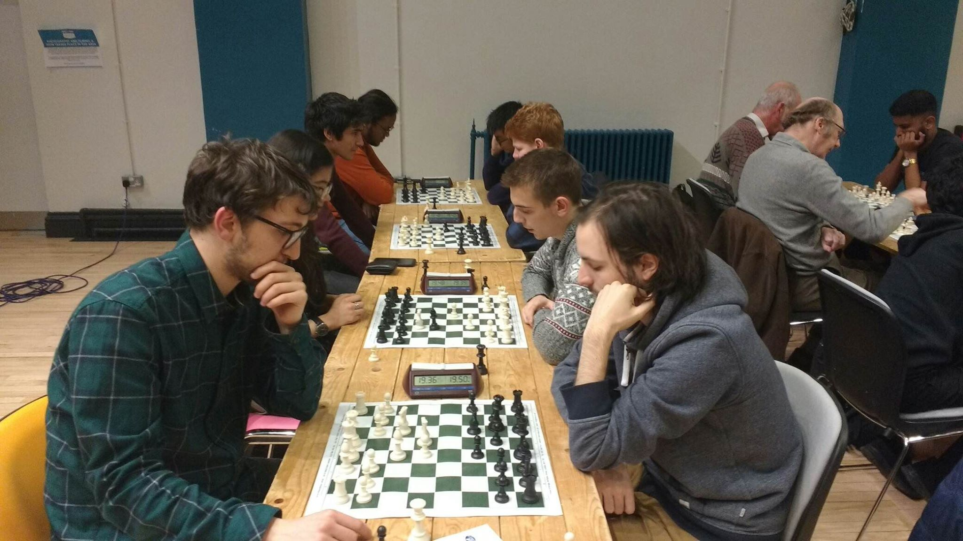
OXFORD RETURN TO 2020 CHESS IN STYLE!
(Birmingham University Midlands Qualifier 25th January 2020)
After a two-year absence former NUCC Champions Oxford University returned back into the 2020 fold just in time for the last qualifier of the season and they didn’t disappoint winning all their five games to triumph.
It is of course the first tournament of ‘2020 Chess’ in the year ‘2020’, adding an extra incentive to everyone to put in a memorable performance. The challengers made Oxford work for it however, especially in the latter stages.
Durham Alumni won their first two games against Reading and Birmingham C to lead the pack and faced Oxford in round three. Phil Purcell on board one for Durham Alumni shocked Oxford’s board one who was rated forty points higher, but the rest of the team couldn’t quite match his efforts as they fell to a 3-1 defeat.
The only Chess Club taking part, Broadlands, were lying next in wait who had their captain fly back from South Africa just days beforehand to make the tournament and also had an Oxford Alumni and a junior in their team. Oxford’s board 2 firmly put the latter in his place with crushing middlegame play that would have cowered even the sharpest of players; and their captain on board four Aloysius ensnared the former in a set of tactics to win a piece and a mating mate; another victory ensued for Oxford.
Although Manchester A had lost out to Broadlands in a narrow 2.5-1.5 reversal the round before, they had an otherwise flawless record as they faced Oxford in the final round (pictured) knowing that they still had a chance of winning the qualifier, but it had to be by a 3 point scoreline due to game points. It was too tall an order against a strong side in fine form as Oxford ran out 3-1 winners in the end.
Meanwhile Durham Alumni dramatically defeated the hosts Birmingham 3-1 in a nail-biting finish to qualify, and Aberystwyth University A squeezed past their bitter rivals Aberystwyth Patzers (Alumni) 2.5-1.5 to join them in the Grand Final.
Our thanks to the University of Birmingham for hosting the event, in particular Ashley Smith and the committee for setting up and booking the tournament hall.
We are as always most grateful to our range of sponsors who provided the prizes and equipment, and also to Oxford University who very generously donated the prize money back to Oxfam so we raised £345 to them as a result.
Peter Hornsby
Founder and Tournament Director of 2020 Chess www.2020chess.com
FINAL TABLE:
POSITION | TEAM | WINS | DRAWS | DEFEATS | TOTAL | (game points)
1st | Oxford | 5 | 0 | 0 | 5 | 16
2nd | Broadlands Chess Club | 4 | 0 | 1 | 4 | 15
3rd | Warwick | 4 | 0 | 1 | 4 | 12.5
4th | Durham Alumni (Q) | 3 | 0 | 2 | 3 | 12
5th | Manchester A (Q) | 3 | 0 | 2 | 3 | 11.5
6th | Aberystwyth University A (Q) | 3 | 0 | 2 | 3 | 11
7th | Bath (Q) | 3 | 0 | 2 | 3 | 11
8th | Birmingham B | 2 | 1 | 2 | 2.5 | 11
9th | Aberystwyth Patzers | 2 | 0 | 3 | 2 | 11.5
10th | Birmingham A | 2 | 0 | 3 | 2 | 10.5
11th | Reading | 2 | 0 | 3 | 2 | 8
12th | Manchester B | 1 | 2 | 2 | 2 | 8
13th | Aberystwyth University B | 1 | 2 | 2 | 2 | 5.5
14th | Birmingham D | 1 | 1 | 3 | 1.5 | 7
15th | Birmingham C | 1 | 0 | 4 | 1 | 4.5

Round One:
Broadland Chess Club 3-0.5 Aberystwyth University A
Durham Alumni 3-1 Reading A
Aberystwyth Patzers 1.5-2.5 Manchester A
Birmingham D 4-0 BYE
Bath 0-4 Oxford
Birmingham C 2.5-1.5 Aberystwyth University B
Manchester B 2-2 Birmingham B
Birmingham A 1-3 Warwick
Round Two:
Birmingham C 0-4 Durham Alumni
Aberystwyth University B 0-4 Birmingham A
Aberystwyth University A 3.5-0.5 Manchester B
Oxford 3-1 Warwick
Manchester A 4-0 Birmingham D
Reading A 0-4 Aberystwyth Patzers
Birmingham B 0-4 Broadland Chess Club
BYE 0-4 Bath

Round Three:
Durham Alumni 1-3 Oxford
Broadland Chess Club 2.5-1.5 Manchester A
Aberystwyth Patzers 1-3 Birmingham A
Manchester B 2-2 Aberystwyth University B
Aberystwyth University A 3-1 Birmingham D
Warwick 3-1 Birmingham B
Bath 3-1 Birmingham C
BYE 0-4 Reading
Round Four:
Oxford 3-1 Broadland Chess Club
Aberystwyth University B 2-2 Birmingham D
Aberystwyth University A 1.5-2.5 Bath
Birmingham A 1.5-2.5 Manchester A
Birmingham C 0.5-3.5 Aberystwyth Patzers
Warwick 3-1 Durham Alumni
Reading 3-1 Manchester B
Birmingham B 4-0 BYE
Round Five:
Manchester A 1-3 Oxford
Durham Alumni 3-1 Birmingham A
Aberystwyth Patzers 1.5-2.5 Aberystwyth University A
Warwick 2.5-1.5 Bath
Manchester B 3.5-0.5 Birmingham C
Birmingham D 0-4 Birmingham B
Broadland Chess Club 4-0 Reading A
Aberystwyth University B 4-0 BYE

INDIVIDUAL RECORD AND SCORES:

NAME | ROUND 1 | ROUND 2 | ROUND 3 | ROUND 4 | ROUND 5 | TOTAL
OXFORD | ✓ | ✓ |  | ½ | ✓ | 3.5
Joris Gerlagh | ✓ | ✓ | ✓ | ✓ | ✓ | 5 GOLD
Filip Mihov | ✓ |  | ✓ | ½ |  | 2.5
Andrew Rogozinski | ✓ | ✓ | ✓ | ✓ | ✓ | 5 GOLD
Aloysius Lip
BATH
Arda Cayonlu |  | ✓ | ✓ |  | ✓ | 3
Oliver Whitfield |  | ✓ | ✓ | ✓ |  | 3
Shuvam Mukhopadhyay |  | ✓ |  | ✓ |  | 2
Jordan de Burgo |  | ✓ | ✓ |  |  | 2
ABERYSTYWTH UNI A
Cameron Westwood |  | ½ | ✓ | ½ | ✓ | 3
Owain Davies | ½ | ✓ |  |  |  | 1.5
Jan Piotrowski |  | ✓ | ✓ |  |  | 2
Marcus Perry |  | ✓ | ✓ | ✓ | ✓ | 4 BRONZE
ABERYSTYWYTH UNI B
Kieran Judge |  |  |  | ✓ | ✓ | 2
Toby Bates | ½ |  | ✓ |  | ✓ | 2.5
Luke McArdle |  |  |  | ✓ | ✓ | 2
Maximilian Stout | ✓ |  | ✓ |  | ✓ | 3
ABERYSTWYTH PATZERS
James Corrigan | ✓ | ✓ |  | ✓ |  | 3
Jamie Friel |  | ✓ | ✓ | ✓ | ½ | 3.5
Daniel Hardman | ½ | ✓ |  | ½ | ✓ | 3
Kit Barker |  | ✓ |  | ✓ |  | 2
READING
Mridul Manoj |  |  | ✓ | ✓ |  | 2
James Connors |  |  | ✓ |  |  | 1
Matthew Brewer |  |  | ✓ | ✓ |  | 2
Shaun Rodrigues | ✓ |  | ✓ | ✓ |  | 3
BROADLAND CHESS CLUB
Richard Polaczek | ✓ | ✓ | ✓ | ½ | ✓ | 4.5 SILVER
Ieysaa bin-Suhayl | ½ | ✓ | ½ |  | ✓ | 3
Gerald Moore | ✓ | ✓ | ✓ | ½ | ✓ | 4.5 SILVER
Paul Badger | ✓ | ✓ |  |  | ✓ | 3
MANCHESTER A
Marco Monti |  | ✓ |  |  |  | 1
Ariana Escobar | ✓ | ✓ | ½ | ✓ |  | 3.5
Louis Krishna Brijmohun | ½ | ✓ |  | ✓ | ✓ | 3.5
Muhd Afiq Abdullah | ✓ | ✓ | ✓ | ½ |  | 3.5
MANCHESTER B |  |  | ✓ |  | ✓
Anish Ananda Baskar |  | ½ | ✓ |  | ✓ | 2.5
Natasha Augustin |  |  |  | ✓ | ½ | 1.5
Fernando Vega Ramón | ✓ |  | ✓ |  | ✓ | 3
Syahmi Azahar | ✓ |  |  |  | ✓ | 2
WARWICK
Partha Mulay | ✓ |  | ✓ |  |  | 2
Ninoslav Pesic |  |  | ✓ | ✓ | ½ | 2.5
Saso Nikic | ✓ | ✓ | ✓ | ✓ | ✓ | 5 GOLD
Paul Behler | ✓ |  |  | ✓ | ✓ | 3
BIRMINGHAM A
Fahim Nasdri |  | ✓ | ✓ | ✓ |  | 3
James Kearney | ✓ | ✓ |  |  |  | 2
James Lee |  | ✓ | ✓ |  | ✓ | 3
Ashley Smith |  | ✓ | ✓ |  |  | 2
BIRMINGHAM B
Maolito Alvarez | ✓ |  |  | ✓ | ✓ | 3
Charlie Sutton | ✓ |  |  | ✓ | ✓ | 3
Nicholas Dimitrov |  |  |  | ✓ | ✓ | 2
Matthew Farward |  |  | ✓ | ✓ | ✓ | 3
BIRMINGHAM C
Steven Apsey | ✓ |  |  |  |  | 1
Joel Mitchell | ½ |  |  |  | ½ | 1
Michael Delaney | ✓ |  | ✓ | ½ |  | 2.5
Ethan Earle
BIRMINGHAM D
Frank Crassley | ✓ |  |  |  |  | 1
Joshua Jacob | ✓ |  | ✓ | ✓ |  | 3
Anad Shah | ✓ |  |  |  |  | 1
Josh Swanbrow | ✓ |  |  | ✓ |  | 2
DURHAM ALUMNI
Phi Purcell | ✓ | ✓ | ✓ | ✓ | ✓ | 5 GOLD
William Grummitt | ✓ | ✓ |  |  |  | 2
James Tapp | ✓ | ✓ |  |  | ✓ | 3
Peter Hornsby |  | ✓ |  |  | ✓ | 2

